JAVA LAB PROGRAM

Submitted by,

Tamilvanan B.

2018503566.

MO Batch.

10-06-2020.

1. Write a java program that triggers, catches and prints the messages for the following built-in exceptions

* Divide a number by zero
* ArrayIndexOutOfBounds Exception
* Numberformat exception
* Nosuchmethod exception

Program

public class P1{

public static void main(String... args){

int a = 12;

int b = 0;

try{

System.out.println(a/b);

}

catch(Exception e){

System.out.println("Zero Division Error handled");

}

int arr[] = {1, 2, 3, 4, 5};

try{

System.out.println(arr[6]);

}

catch(Exception e1){

System.out.println("ArrayIndexOutOfBoundsException handled");

}

String str = "12.23";

try {

int d = Integer.parseInt(str);

}

catch(Exception e2){

System.err.println("NumberFormatException handled");

}

try {

Integer.class.getMethod("unidentified");

}

catch(Exception e3){

System.out.println("NoSuchMethodError handled");

}

}

}

Output

2.  Write a program to illustrate the usage of multiple catch statements occurring in a program. The program should also show sub  class exception  precedence  over  base  class.

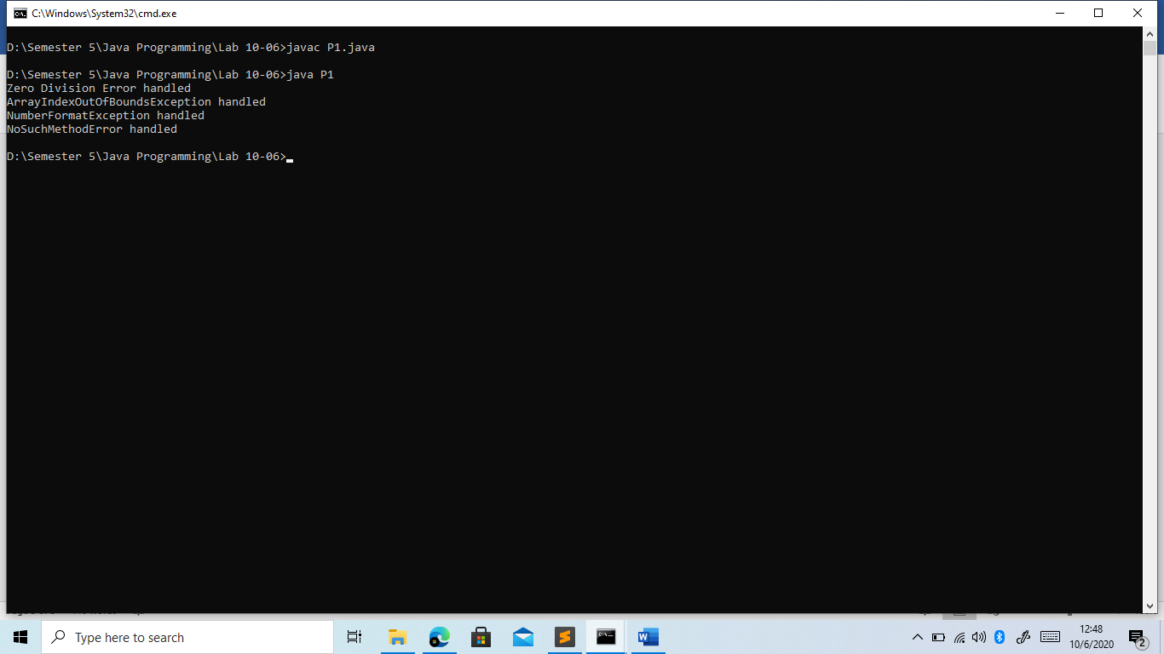Program

import java.io.\*;

public class Q2{

public static void main(String[] args){

try{

String str = "msh";

System.out.println(str.charAt(5));

}

catch(StringIndexOutOfBoundsException e){

System.out.println(e);

}

catch(IndexOutOfBoundsException e){

System.out.println(e);

}

catch(Exception e){

System.out.println(e);

}

}

}

Output

